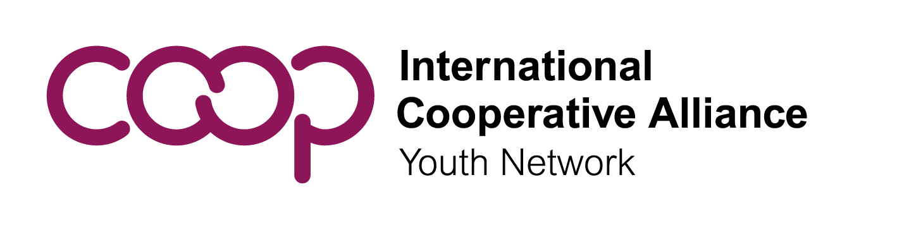

|  |
| --- |
| Call for Nominations: ICA Youth Committee (ICA YC)  President |

How to nominate youth representatives to vote and run for office

ICA member organizations may nominate two youth representatives (hereafter named representatives) under the age of 35 years to the ICA YC. To apply for membership in the ICA YC, interested member organisations must submit an application at least six weeks before the Annual Plenary Meeting. Application forms are available [here](https://globalyouth.coop/en/media/library/governance-materials/ica-yc-membership-form).

Youth Representatives nominated by ICA member organizations may themselves nominate a maximum of 10 other appropriate youth from their own countries as youth representatives.

ICA Member organisations may nominate candidates from the already nominated Youth Representatives to the elections of ICA-YC Executive Committee at least six weeks before date of voting.

Roles & Responsibilities of the Executive Committee

The Executive Committee of the ICA YC shall consist of four Vice-presidents elected by regional youth committees, four Members at large and President elected directly by representatives of the Annual Plenary Meeting.

The Role of the Executive Committee is to ensure that the ICA YC achieves its aims and provide overall leadership and management. The Executive Committee will convene an Annual Plenary Meeting of the ICA-YC and other meetings related to its work with youth cooperators. It shall regularly review the ICA YC work plan, set benchmarks for success, and report progress to the ICA Board and ICA General Assembly.

The role of the President of the ICA YC is to represent all young cooperators at the global level. In addition to the specific functions that may be assigned by the Executive Committee, they shall have the following functions:

a. Call and preside meetings of the ICA Youth Committee, ICA Youth Network and the ICA YC Executive Committee;

b. Represent youth cooperators at the ICA Board as the ICA Youth Representative;

c. Oversee the implementation of ICA YC action plan;

d. Serve as liaison and promote dialogue between the ICA Youth Network and the Executive Committee with International Cooperative Alliance and related bodies;

e. Represent the ICA before third parties and international bodies as required with the prior approval of the ICA- YC;

The Executive Committee meets regularly online and occasionally in person. The meetings are conducted in English.

Learn more about the election from the rules of the ICA YC [here](https://www.globalyouth.coop/en/media/library/governance-materials/ica-youth-committee-rules).

Timeline & Form Requirements

The ICA YC will hold its next **Annual Plenary Meeting on 3 July in Manchester, United Kingdom**. If you would like to submit a nomination for the President, send this nomination form to Mrs. Gretchen Hacquard at [hacquard@ica.coop](mailto:hacquard@ica.coop) no later than **22 May** with the subject line “ICA YC Nomination” along with the following documents:

* The nomination form duly signed and completed
* Full curriculum vitae (CV) of the candidate
* A photo of the candidate
* Short bio of the candidate to be used for social media purposes (no more than 200 words)
* Motivation letter by the candidate explaining WHY the candidate is interested in the position
* A short video that will be posted on the youth network website (no more than 3 minutes)

Please take into consideration that any nomination form that arrives after 22 May will not be considered valid.

Qualifications

Candidates for the position must:

* Have full financial support from their nominating organisation that would pay for all the expenses of the person to be nominated. The budget should envision participation in four international events per year including the ICA Board, ICA General Assembly and the Youth Committee.
* Take part in regular electronic meetings of the Executive Committee.

The Youth Committee recommends, based on past experience, that candidates:

* + Be able to speak and write in English, but not exclusively, in order to facilitate communication. Executive Committee members must arrange for their own interpretation if they do not speak English.
  + Have knowledge of youth issues, youth participation and the cooperative movement.
  + Be able to convey and amplify the views of youth and their diversity at the global level. Be able to use various communications tools including social media to convey important messages to youth globally.
  + Have time to dedicate to the Global Youth Committee and its network. This is not only a representative role, but the candidates will also be part of the team that does the work to make the Youth Committee work plan successful.
* Ensure that you do not exceed the age of 35 before the end of the term of office (before the end of 2026).

|  |
| --- |
| Nomination Form  President of the Youth Committee |

Candidate

|  |  |  |  |  |
| --- | --- | --- | --- | --- |
| Family Name (Last / Surname) |  | Given Name (First) |  | |
| Organisation |  | | | |
| Position/Title |  | Country |  | |
| Address |  | | | |
| Email |  | | Gender |  |
| Please attach: | * Full curriculum vitae (CV) of the candidate * A photo of the candidate * Short bio of the candidate to be used for social media purposes (no more than 200 words) * Motivation letter by the candidate explaining WHY the candidate is interested in the position * A short video that will be posted on the youth network website (no more than 3 minutes) | | | |

Nominating Member Organisation

|  |  |  |  |
| --- | --- | --- | --- |
| Organisation |  | | |
| Address |  | | |
| Country |  | Telephone |  |
| Email |  | | |

Signatory of Nominating Member Organisation & Candidate

|  |  |  |  |
| --- | --- | --- | --- |
| Nominating Member Organisation | | Candidate | |
| Hereby certifies that the candidate is qualified and fully understands the roles, responsibilities and costs related to this position and agrees to support the candidate. | | I am fully aware of the roles and responsibilities related to the position on the Executive Committee as set forth in the Rules of the ICA Youth Committee[1] and hereby conform my suitability for office. | |
| Name and title of signatory |  |
| Signature |  | Signature |  |
| Date |  | Date |  |

Submit this form duly filled with the required documents no later than 22 May 2025 at midnight to[**hacquard@ica.coop**](mailto:hacquard@ica.coop)**.** Late forms will not be valid.

1. ICA Youth Committee rules can be downloaded online at <https://www.globalyouth.coop/en/media/library/governance-materials/ica-youth-committee-rules>