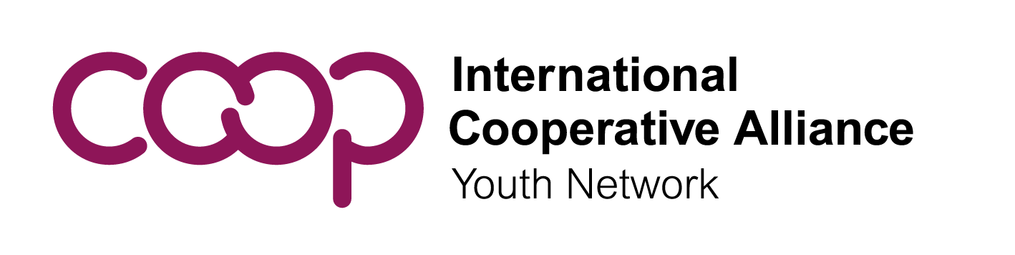

Call for Nominations: ICA Youth Committee (ICA YC), Executive Committee Members at Large

Invitation to the ICA YC meeting on September 13, 2026, in Panama and Call for Nominations for the Executive Committee
Dear ICA YC members:
The ICA Youth Committee (ICA YC) is pleased to invite members to the upcoming Annual Plenary Meeting, which will take place in person and virtually on September 13, at 3:00 PM Panama time. The purpose of this meeting will be to elect the Members at Large of the ICA Executive Committee and obtain member input on the next 4-year work plan. Please mark your calendars to attend!
The ICA Youth Committee is also inviting ICA members to nominate candidates for the Executive Committee. This is an excellent opportunity for young people to learn more about the global cooperative movement, make a difference at a global level, and learn valuable leadership and collaboration skills. We are especially looking for young people who are motivated to help us implement the next four-year work plan. To learn more, click here. Nomination forms must be submitted by 15 July, 2026.
Dear ICA members:
The ICA Youth Committee (ICA YC) is organizing an in person Annual Plenary Meeting on September 13 , at 3:00 PM Panama time. The purpose of this meeting will be to elect the Members at Large of the ICA Executive Committee and obtain member input on the next 4-year work plan. We call upon all ICA members to nominate young members to the ICA Executive Committee so they can vote and provide input on the Executive Committee's next four-year work plan.
To learn more about how to nominate members, click here. Membership forms must be submitted by 30 June to be able to vote at the Annual Plenary Meeting. We are also inviting ICA members to nominate candidates for the ICA Executive Committee. This is an excellent opportunity for young people to learn more about the global cooperative movement, make a difference at a global level, and learn valuable leadership and collaboration skills. We are especially looking for young people who are motivated to help us implement the next four-year work plan.
For more information and to download the nomination form, click here. Nomination forms for the ICA Executive Committee must be submitted by July 15th , 2026.
About the ICA YC Executive Committee
The ICA YC Executive Committee will consist of four Vice-Presidents elected by regional youth committees, four Members at Large, and the President elected directly by representatives at the Annual Plenary Meeting. The role of the Executive Committee is to ensure that the ICA YC achieves its objectives and to provide general leadership and management. The Executive Committee will convene an Annual Plenary Meeting of the ICA YC and other meetings related to its work with young cooperators. It will periodically review the ICA YC work plan, establish benchmarks for success, and report progress to the ICA Board and the ICA General Assembly.
ICA YC Members at Large, one for each ICA region, will be nominated by ICA members. They are elected directly by ICA YC representatives at the time of the Presidential election. They will be responsible for facilitating the participation of ICA member organizations at the regional level in youth activities promoted by the ICA YC and supporting the Executive Committee in its tasks.
The Executive Committee meets regularly online and occasionally in person. Meetings are conducted in English. The term for Members at Large is four years; therefore, it is requested that candidates be no older than 31 so they do not exceed age 35 during their term. Nominations must be received no later than 6 weeks before the Annual Plenary Meeting. Learn more about the election from the ICA YC rules here.
Timeline and Form Requirements
The ICA YC will hold its next Annual Plenary Meeting in person and online on September 13, 2026, at 3:00 PM (Panama time). If you wish to submit a nomination for a Member at Large, please send this nomination form to Ms. Ingrid Colanero at colanero@ica.coop no later than July 15th with the subject line "Youth Executive Committee Nomination," along with the following documents:
- The duly signed and completed nomination form
- Full Curriculum Vitae (CV) of the candidate
- A photo of the candidate
- A brief biography of the candidate for social media use
- A motivation letter explaining the interest in the position
- Optional: A short video for the official website
Please note that any nomination form arriving after 15 July 2026, will not be considered valid. The Executive Committee is elected by Youth Committee members endorsed by an ICA member and will be ratified by the Annual Plenary Meeting. The election will take place electronically and in person over 24 hours starting from the Annual Plenary Meeting on September 13, 2026.
Qualifications
Candidates for the position must:
- Have full financial support from their proposing organization to cover all expenses.
- Budget for one in-person meeting per year.
- Participate in regular electronic meetings of the Executive Committee.
Based on previous experience, the Youth Committee recommends that candidates:
- Be able to speak and write in English to facilitate communication.
- Arrange their own interpretation if they do not speak English.
- Have knowledge of youth issues, youth participation, and the cooperative movement.
- Be able to convey and amplify the diverse views of youth globally.
- Be able to use various communication tools, including social media.
- Have time to dedicate to the Global Youth Committee and its network.
- Understand this is an active work role, not just a representative one.
- Be 31 years old or younger to not exceed 35 during the four-year term.

Nomination Form: Executive Committee Member at Large
Candidate Information:
- Last Name, First Name
- Organization, Position/Title, Country, Address, Email, Gender
- Attachments: CV, Photo, Brief Bio (max 100 words), Motivation Letter
Nominating Member Organization:
- Organization Name, Address, Country, Phone, Email
Signatures:
- Nominating Organization Signatory (Name, Title, Signature, Date)
- Candidate (Declaration of awareness of obligations, Signature, Date)

