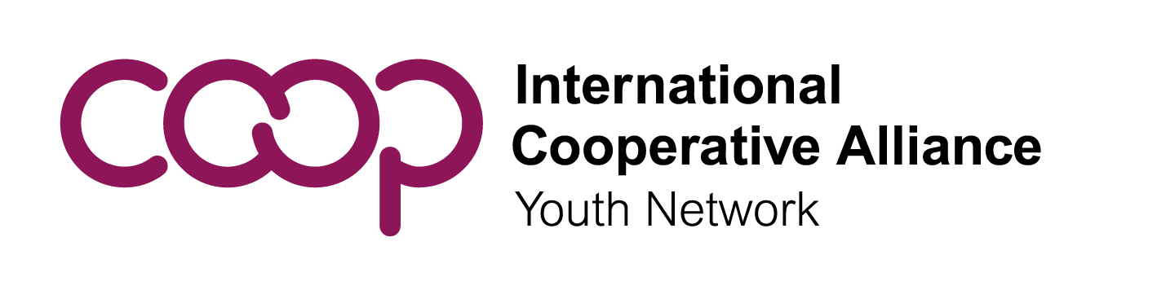

Call for Nominations: ICA Youth Committee (ICA YC)
Executive Committee Members At Large
The ICA Youth Committee is inviting ICA members to nominate At Large candidates to the Executive Committee. This is an excellent opportunity for youth to learn more about the global cooperative movement, make a difference globally, and learn valuable collaborative leadership and skills. We are especially looking for youth who will be motivated to help us implement the next four-year work plan. To learn more, click here. Nomination forms are due no later than 17 August.
About the Executive Committee of the ICA YC

The Executive Committee of the ICA YC shall consist of four Vice-presidents elected by regional youth committees, four Members at large and President elected directly by representatives of the Annual Plenary Meeting.

The Role of the Executive Committee is to ensure that the ICA YC achieves its aims and provides overall leadership and management. The Executive Committee will convene an Annual Plenary Meeting of the ICA YC and other meetings related to its work with youth cooperators. It shall regularly review the ICA YC work plan, set benchmarks for success, and report progress to the ICA Board and ICA General Assembly.

ICA-YC Members at large one per ICA Region, shall be nominated by ICA members. They are elected directly by the ICA YC representatives at the time of electing the President.

They shall be responsible for facilitating engagement of ICA member organizations at the regional level, on youth activities promoted by the ICA YC, and in supporting the Executive Committee with its tasks.

The Executive Committee meets regularly online and occasionally in person. The meetings are conducted in English.

The term of office for Members At Large is four years and thus it is requested that the candidate be no older than 31 years old so that they do not exceed the age of 35 during their term of office. Nominations must be received no later than 6 weeks before the Annual Plenary Meeting. Learn more about the election from the rules of the ICA YC here.
Timeline & Form Requirements
The ICA YC will hold its next Annual Plenary Meeting online on 28 September 2022 at 2pm (Brussels time). If you would like to submit a nomination for a Member At Large, send this nomination form to Mrs. Gretchen Hacquard at hacquard@ica.coop no later than 17 August 2022 with the subject line “Youth Executive Committee Nomination” along the following documents:

- The nomination form duly signed and completed
- Full curriculum vitae (CV) of the candidate
- A photo of the candidate
- Short bio of the candidate to be used for social media purposes
- Motivation letter by the candidate explaining WHY the candidate is interested in the position
- Optional: a short video that will be posted on our official website

The Executive Committee is elected by the Youth Committee members that were endorsed by an ICA member, and she/he will be ratified by the Annual Plenary Meeting. The election will take place electronically for 24 hours starting during the Annual Plenary Meeting to be held on 28 September 2022 at 2pm.
Qualifications
Candidates for the position must:
- Have full financial support from their nominating organisation that would pay for all the expenses of the person to be nominated. The budget should envision one meeting in-person per year.
- Take part in regular electronic meetings of the Executive Committee.
The Youth Committee recommends, based on past experience, that candidates:
  - Be able to speak and write in English, but not exclusively, in order to facilitate communication. Executive Committee members must arrange for their own interpretation if they do not speak English.
  - Have knowledge of youth issues, youth participation and the cooperative movement.
  - Be able to convey and amplify the views of youth and their diversity at the global level. Be able to use various communications tools including social media to convey important messages to youth globally.
  - Have time to dedicate to the Global Youth Committee and its network. This is not only a representative role, but the candidates will also be part of the team that does the work to make the Youth Committee work plan successful.
- Be 31 or younger so that they do not exceed the age of 35 during their four years in office.

Nomination Form
Executive Committee Member At Large
Candidate
Family Name (Last / Surname) |  | Given Name (First)
Organisation
Position/Title |  | Country
Address
Email |  |  | Gender
Please attach: | - Full curriculum vitae  - Recent photo  - Brief biographical note (maximum 100 words)  - Motivation letter
Nominating Member Organisation
Organisation
Address
Country |  | Telephone
Email
Signatory of Nominating Member Organisation & Candidate
Nominating Member Organisation |  | Candidate
Name and title of signatory |  | I am fully aware of the duties related to the position on the Executive Committee as set forth in the Rules of the ICA Youth Committee and hereby conform my suitability for office.
Signature |  | Signature
Date |  | Date
Submit this form duly filled with the required documents no later than 17 August 2022 at midnight to hacquard@ica.coop. Late forms will not be valid.

ICA Youth Committee rules can be downloaded online at https://www.globalyouth.coop/en/media/library/governance-materials/ica-youth-committee-rules

